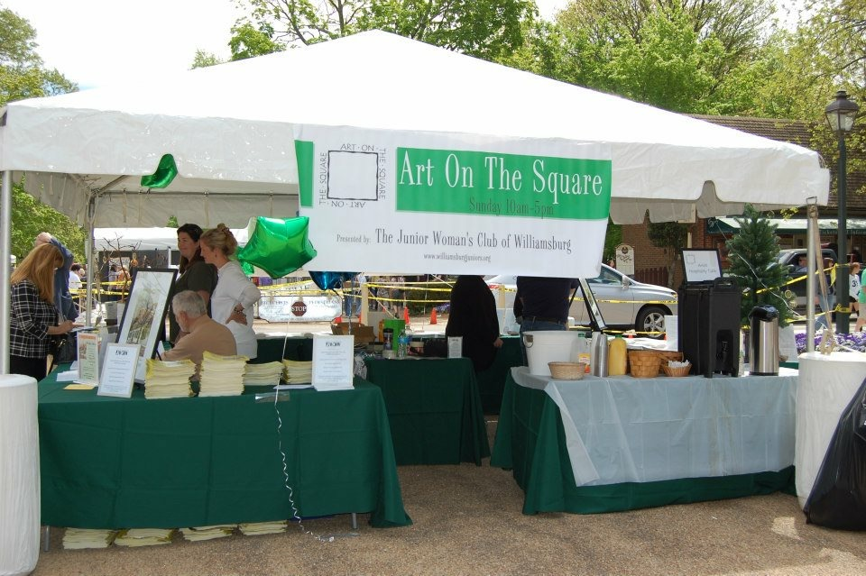

54th Annual Art on the Square

WILLIAMSBURG, VA— The Junior Woman’s Club of Williamsburg (JWCW) presents the 54th annual Art on the Square on Sunday, April 30, 2017 from 10 a.m. to 5 p.m. in Merchants Square to help support the local art community.

Art on the Square is open to the public. Visitors can purchase raffle tickets at the JWCW main tent for a chance to win an original piece from featured artist, Richard DePaul.

Over 165 artists from across the country will participate in Art on the Square to display their artwork. Stroll along Duke of Gloucester Street and North Boundary Street to view original paintings, ceramics, photography and jewelry.

“We are excited this year’s Art on the Square will feature artwork from new faces. Visitors will be impressed by the depth and diversity of the works,” said Tori Otstot, president of JWCW. “Through this event, we are able to support great organizations dedicated to preserving and growing the arts.”

Proceeds from artist booth fees and raffle ticket sales are donated to visual and performing arts organizations throughout the greater Williamsburg area.

Nora Bartlett of Walls Alive will be offering special framing pricing for Art on the Square posters featuring Depaul’s signature piece this year. Customers who visit the store and mention JWCW, Nora will donate a portion of the proceeds of framing sales to the for local arts donations.

Parking is available throughout Merchants Square. After the show, check out the 2017 Williamsburg Craft Beer Festival at the Williamsburg Library from 1p.m. to 5 p.m.

[BOILER]

