**Media Contact**

Erica Hammett

Juniors Woman’s Club of Williamsburg

ericahammett93@gmail.com

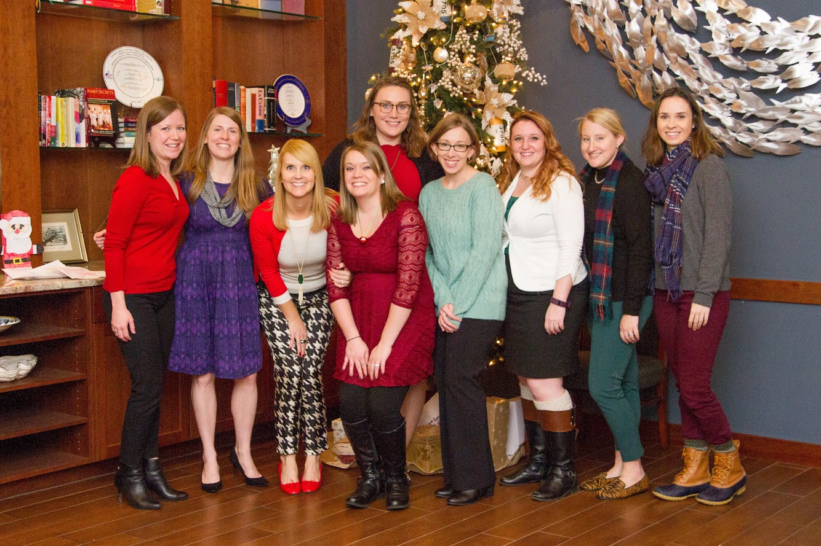

**Junior Woman’s Club of Williamsburg to Host Ninth Annual Breakfast with Santa**

WILLIAMSBURG, VA— Santa Claus is coming to town on December 9, 2017 for The Junior Woman’s Club of Williamsburg (JWCW) ninth annual [Breakfast with Santa](http://www.williamsburgjuniors.org/breakfast-with-santa) at Waypoint Seafood & Grill.

This annual breakfast buffet fuels the community by giving back to local non-profits and high school scholarships through the JWCW general donation fund. Breakfast with Santa is a family-friendly event featuring a full breakfast buffet, complimentary photos by local photographer Heather Booysen, crafts and raffle wreaths.

“We look forward to welcoming back families who have made Breakfast with Santa a tradition and newcomers who want to spend time with family,” says Tori Otstot, JWCW president. “This event is a great way to get into the holiday spirit and give back to the local community.”

Tickets are required and may be purchased [online](https://events.r20.constantcontact.com/register/eventReg?oeidk=a07eeqq1dl9a96c68a9&oseq=&c=&ch=) through Monday, Dec. 4, 2017. Tickets are $25 for adults, $10 for children ages 3 to 12 and two and younger are free. Seating times are in 15- to 30- minutes intervals from 7:30 to 10:30 a.m. Booster seats and high chairs are available.

**About Junior Woman's Club of Williamsburg**

Established in 1954 as a 501 (c) (4) non-profit for civic-minded women with a mission to live each day with a purpose. The volunteer organization supports a wide variety of charitable organizations and community services through financial and volunteer assistance and hosts four yearly fundraising events with proceeds donated locally in the form of mini-grants to other non-profit organizations and awarded as scholarships to high school seniors.

###