Media Contact:
Lauren Moore
General Manager, DoG Street Pub
Lmoore@dogstreetpub.com
757-293-6478

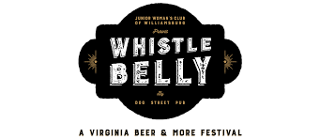

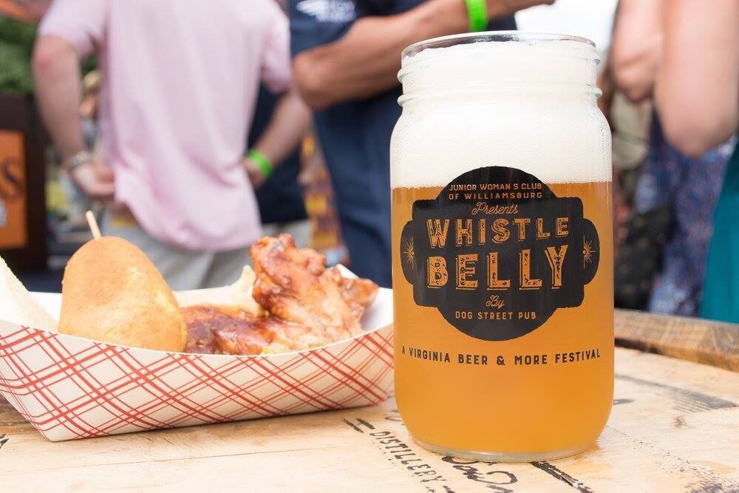
2018 Whistle Belly Beer & More Festival Supports Craft Beer and Community

WILLIAMSBURG, Va. — Colonial Americans created a drink called Whistle Belly to revive expired beer by boiling a reddish brown ale and adding molasses. DoG Street Pub wanted to create a beer festival that was connected to the colonial era and involved beer.

In an effort to enrich the community and help local nonprofits, DoG Street Pub teamed up with the Junior Woman’s Club of Williamsburg (JWCW) to combine their love of craft beer and the community.

The fourth annual Whistle Belly benefiting the JWCW will be held on Saturday, August 4 from 7 to 11 p.m. in Colonial Williamsburg’s Merchants Square. This year’s event is expanding to Duke of Gloucester Street and is in the evening to encourage guests to shop, dine and explore historic Colonial Williamsburg.

Whistle Belly will host over 35 breweries and feature wine for the first time from The Williamsburg Winery. In addition to The Catering Company, Chef David Everett’s restaurants, DoG Street Pub, Trellis Bar & Grill, Blue Talon Bistro and Culture Café, will cater sweet and savory dishes. State fair-inspired treats such as corn dogs, wings and funnel cake sticks will be available. Guests can also enjoy live music by Irish rock band, The Fighting Jamesons along with corn hole and giant jenga.
Located at The Williamsburg Winery, Wedmore Place at Wessex Hundred is offering guests 10% off stays on August 3 and August 4 by calling (757) 941-0310. Colonial Williamsburg hotels including, Griffin Hotel, Colonial Houses, Williamsburg Inn and Woodlands Hotel & Suites will offer 15% off stays August 1 through August 6 when using promo code DOG during online booking.

“Whistle Belly is a craft beer and food festival that elevates an evening of libations into an adventure of more than 70 beers and state fair inspired food,” says Lauren Moore, General Manager of DoG Street Pub and Whistle Belly organizer. “Whistle Belly has become the premier Williamsburg beer event that raises money for a worthy nonprofit.”

The 2018 Whistle Belly will offer VIP early admission starting at 6 p.m. sponsored by Alewerks Brewing Company and Billsburg Brewery for $70 to sample 10 exclusive beers in addition to the 80 beers available. General admission is $50 inclusive of food and drink.

“Whistle Belly is always a fun way for JWCW to kick off our club year,” says Kate Teiken, JWCW president. “It is the first of several events we host throughout the year that help us to raise thousands of dollars that we are able to put right back into our community.”

To purchase event tickets and learn more, please visit whistlebelly.com. Proceeds from raffle tickets benefit local non-profits and scholarships to high school students via JWCW.

Images (courtesy of Abigail Darrin)

Dropbox:
https://www.dropbox.com/sh/1oxjytx726vkgoz/AADLXqqJZFvqGnUz4W8U-ZLja?dl=0

About DoG Street Pub
Simply presented, excellent food without the rubbish, DoG Street Pub is located in Merchants Square, Williamsburg. Once an 80-year-old bank now an American gastropub that provides personal service with quality cuisine in a casual setting. In June 2012 David Everett opened DoG Street Pub committed to honoring the dignity and heritage of its namesake, Duke of Gloucester Street. DoG Street Pub understands a superb craft beer is the perfect complement to a meal and scours the globe to accommodate all tastes, from the casual fan to seasoned enthusiast whose favorite is "something new."

About Junior Woman’s Club of Williamsburg
Established in 1954 as a volunteer organization for civic-minded women, our mission is to live each day with a purpose. As a 501(c)(4) non-profit, we support a wide variety of charitable organizations and community services through financial and volunteer assistance. We hold several fundraising events each year and proceeds are donated locally in the form of mini-grants to other non-profit organizations and awarded as scholarships to high school seniors.
###

